Using data validation controls view medal tallies
In this completed basic dashboard example, you'll find the medal statistics by country taken from the 2016 Olympic Games held in Brazil.
You are going to use the data validation controls to view the gold, silver, and bronze medal tallies for Australia.

Instructions
100XP
- Change the country to Australia using the drop-down menu.

2016 SUMMER OLYMPIC MEDAL TABLE
Country | Gold | Silver | Bronze | Country | Gold | Silver | Bronze
Australia (AUS) | 8 | 11 | 10 | United States (USA) | 46 | 37 | 38
 |  |  |  | Great Britain (GBR) | 27 | 23 | 17
 |  |  |  | China (CHN) | 26 | 18 | 26
 |  |  |  | Russia (RUS) | 19 | 17 | 19
 |  |  |  | Germany (GER) | 17 | 10 | 15
 |  |  |  | Japan (JPN) | 12 | 8 | 21
 |  |  |  | France (FRA) | 10 | 18 | 14
 |  |  |  | South Korea (KOR) | 9 | 3 | 9
 |  |  |  | Italy (ITA) | 8 | 12 | 8
 |  |  |  | Australia (AUS) | 8 | 11 | 10
Rank | Country | Total Medals
2 | Great Britain (GBR) | 67
4 | Russia (RUS) | 55
6 | Japan (JPN) | 41
8 | South Korea (KOR) | 21
10 | Australia (AUS) | 29

Good work! You can now see how data validation can be used in a dashboard to allow a user to select from a list.

Using data validation controls to pick from a list
In the dashboard example, you are going to pick sequential numbers from a list to order countries by medal rankings. In this exercise, you will be sorting the countries by total number of medals, but country rank in the Olympics is typically determined by the number of Gold medals per country. Ties are broken using silver medals, and then bronze medals.

Instructions
100XP
- Change the rank using the drop-down menu so that the ranks are displayed in order for countries 1 through 5.

2016 SUMMER OLYMPIC MEDAL TABLE
Country | Gold | Silver | Bronze | Country | Gold | Silver | Bronze
United States (USA) | 46 | 37 | 38 | United States (USA) | 46 | 37 | 38
 |  |  |  | Great Britain (GBR) | 27 | 23 | 17
 |  |  |  | China (CHN) | 26 | 18 | 26
 |  |  |  | Russia (RUS) | 19 | 17 | 19
 |  |  |  | Germany (GER) | 17 | 10 | 15
 |  |  |  | Japan (JPN) | 12 | 8 | 21
 |  |  |  | France (FRA) | 10 | 18 | 14
 |  |  |  | South Korea (KOR) | 9 | 3 | 9
 |  |  |  | Italy (ITA) | 8 | 12 | 8
 |  |  |  | Australia (AUS) | 8 | 11 | 10
Rank | Country | Total Medals
1 | United States (USA) | 121
2 | Great Britain (GBR) | 67
3 | China (CHN) | 70
4 | Russia (RUS) | 55
5 | Germany (GER) | 42

Great stuff! How easy is it to modify a display using the nifty data validation function?

Using conditional formatting on a dashboard
Conditional formatting is another functionality that completed dashboards can contain that allows users to modify the visual display on the dashboard. Here, you will explore the conditional formatting on the same dashboard for the 2016 Olympic Games in Brazil.

Instructions
100XP
- Highlight Gold, Silver, and Bronze figures for the 10 countries and adapt the 'Conditional formatting' to display values that are greater than or equal to 25.

Hint
- The Gold, Silver, and Bronze medal tallies are in F3:H12.
- To use conditional formatting, go to Format, then Conditional formatting.

2016 SUMMER OLYMPIC MEDAL TABLE
Country | Gold | Silver | Bronze | Country | Gold | Silver | Bronze
United States (USA) | 46 | 37 | 38 | United States (USA) | 46 | 37 | 38
 |  |  |  | Great Britain (GBR) | 27 | 23 | 17
 |  |  |  | China (CHN) | 26 | 18 | 26
 |  |  |  | Russia (RUS) | 19 | 17 | 19
 |  |  |  | Germany (GER) | 17 | 10 | 15
 |  |  |  | Japan (JPN) | 12 | 8 | 21
 |  |  |  | France (FRA) | 10 | 18 | 14
 |  |  |  | South Korea (KOR) | 9 | 3 | 9
 |  |  |  | Italy (ITA) | 8 | 12 | 8
 |  |  |  | Australia (AUS) | 8 | 11 | 10
Rank | Country | Total Medals
2 | Great Britain (GBR) | 67
4 | Russia (RUS) | 55
6 | Japan (JPN) | 41
8 | South Korea (KOR) | 21
10 | Australia (AUS) | 29

Well done! Let's now look at the very basics of setting up your own Dashboard.

Creating a column chart from your data
In the dataset you'll find the medal statistics by country from the 2016 Olympic Games held in Brazil in order of ranking. Let's use the data to create a column chart to show the medal tallies of the first 3 ranked countries.

Instructions
100XP
- Highlight the Country, and then the Gold, Silver, and Bronze medal stats for the first three ranked countries, then create a column chart and move it to the right of the data.

2016 Summer Olympics medal table
Rank | Country | Gold | Silver | Bronze | TOTAL
1 | United States (USA) | 46 | 37 | 38 | 121
2 | Great Britain (GBR) | 27 | 23 | 17 | 67
3 | China (CHN) | 26 | 18 | 26 | 70
4 | Russia (RUS) | 19 | 17 | 19 | 55
5 | Germany (GER) | 17 | 10 | 15 | 42
6 | Japan (JPN) | 12 | 8 | 21 | 41
7 | France (FRA) | 10 | 18 | 14 | 42
8 | South Korea (KOR) | 9 | 3 | 9 | 21
9 | Italy (ITA) | 8 | 12 | 8 | 28
10 | Australia (AUS) | 8 | 11 | 10 | 29
11 | Netherlands (NED) | 8 | 7 | 4 | 19
12 | Hungary (HUN) | 8 | 3 | 4 | 15
13 | Brazil (BRA)* | 7 | 6 | 6 | 19
14 | Spain (ESP) | 7 | 4 | 6 | 17
15 | Kenya (KEN) | 6 | 6 | 1 | 13
16 | Jamaica (JAM) | 6 | 3 | 2 | 11
17 | Croatia (CRO) | 5 | 3 | 2 | 10
18 | Cuba (CUB) | 5 | 2 | 4 | 11
19 | New Zealand (NZL) | 4 | 9 | 5 | 18
20 | Canada (CAN) | 4 | 3 | 15 | 22
21 | Uzbekistan (UZB) | 4 | 2 | 7 | 13
22 | Kazakhstan (KAZ) | 3 | 5 | 10 | 18
23 | Colombia (COL) | 3 | 2 | 3 | 8
24 | Switzerland (SUI) | 3 | 2 | 2 | 7
25 | Iran (IRI) | 3 | 1 | 4 | 8
26 | Greece (GRE) | 3 | 1 | 2 | 6
27 | Argentina (ARG) | 3 | 1 | 0 | 4
28 | Denmark (DEN) | 2 | 6 | 7 | 15
29 | Sweden (SWE) | 2 | 6 | 3 | 11
30 | South Africa (RSA) | 2 | 6 | 2 | 10
31 | Ukraine (UKR) | 2 | 5 | 4 | 11
32 | Serbia (SRB) | 2 | 4 | 2 | 8
33 | Poland (POL) | 2 | 3 | 6 | 11
34 | North Korea (PRK) | 2 | 3 | 2 | 7
35 | Belgium (BEL) | 2 | 2 | 2 | 6
36 | Thailand (THA) | 2 | 2 | 2 | 6
37 | Slovakia (SVK) | 2 | 2 | 0 | 4
38 | Georgia (GEO) | 2 | 1 | 4 | 7
39 | Azerbaijan (AZE) | 1 | 7 | 10 | 18
40 | Belarus (BLR) | 1 | 4 | 4 | 9
41 | Turkey (TUR) | 1 | 3 | 4 | 8
42 | Armenia (ARM) | 1 | 3 | 0 | 4
43 | Czech Republic (CZE) | 1 | 2 | 7 | 10
44 | Ethiopia (ETH) | 1 | 2 | 5 | 8

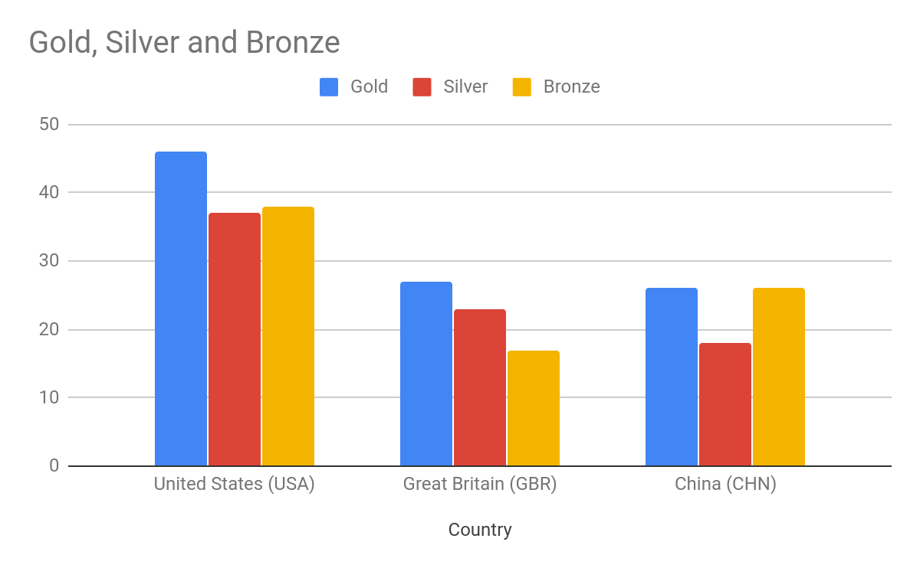

Good work! How easy was that! Here, you created a chart on the same page as your data, but there may be situations where you only want to display the data you will chart on your dashboard.

Setting up your worksheet with formulas of reference
In this next task, you will showcase only the data you want to chart using formulas of reference to extract the top 3 countries' medal tallies from the dataset and show them in the dashboard.

Instructions
0XP
- Create a formula of reference in cell A1 that shows the contents of A1 in the Olympics sheet.
- Copy the calculation down and across the sheet to show all data for the first 3 ranked countries.
- Make sure column B is wide enough to see the entire country name.

Ans :

=Olympics!A1

Sheet1 -->

2016 Summer Olympics medal table
3 | Country | Gold | Silver | Bronze
1 | United States (USA) | 46 | 37 | 38
2 | Great Britain (GBR) | 27 | 23 | 17
3 | China (CHN) | 26 | 18 | 26

Olympics -->

2016 Summer Olympics medal table
Rank | Country | Gold | Silver | Bronze | TOTAL
1 | United States (USA) | 46 | 37 | 38 | 121
2 | Great Britain (GBR) | 27 | 23 | 17 | 67
3 | China (CHN) | 26 | 18 | 26 | 70

Great work, you now have only the medal tally data from the first 3 countries on your worksheet! Certainly a cleaner and less busy look. Remember, you could also format the headings in some way.

Charting the medal statistics
Now that you have only the data you want to chart in this task you will create a column chart and display it underneath your extracted data.

Instructions
100XP
- Create a column chart showing the Country, Gold, Silver, and Bronze stats.
- Position the chart underneath the data.

2016 Summer Olympics medal table
Rank | Country | Gold | Silver | Bronze
1 | United States (USA) | 46 | 37 | 38
2 | Great Britain (GBR) | 27 | 23 | 17
3 | China (CHN) | 26 | 18 | 26

Well done. We now have the beginnings of a "clean" dashboard, charting only the extracted data.

Getting started
Setting up your data in the correct way in the beginning will save you lots of time and effort later on. Here, you will set up your data so you have an efficient spreadsheet to work with as you create your dashboard.

Instructions
100XP
- Remove all rows from the dataset that are empty.

Shark Attacks in Australia - Last 100 Years |  |  |  |  |  | Today's Date | 8/29/2019
State | # Cases | Fatal | Injured | Uninjured
NSW | 221 | 47 | 119 | 55
QLD | 161 | 52 | 91 | 18
WA | 92 | 17 | 59 | 16
SA | 43 | 13 | 22 | 8
VIC | 34 | 3 | 20 | 11
TAS | 10 | 1 | 5 | 4
NT | 8 | 1 | 6 | 1
Total | 569 | 134 | 322 | 113
Average Fatalities per Year |  | 19

Good work. Remember that if you have any merged cells, it is best to unmerge them. You can also right align all numbers by using Ctrl (or command) + Shift + r or the alignment tool on the toolbar.

Format dates and numbers
To make your data clear at a glance, in this task you will apply a little bit of formatting to your data.

Instructions
100XP
- Format the date so that it shows the day as a number, month in full, and year (e.g. '1 January 2000'). Then widen the column so you can see it all.
- Ensure all numbers have 2 decimal places by highlighting the correct cells, and then using the arrow controls in the toolbar (next to the '123' drop-down menu).
- Note, to pass this exercise you need to use the arrow controls in the toolbar to adjust the decimal places, and not alternative number formatting options.

=today()

=SUM(C3:C9)

Shark Attacks in Australia - Last 100 Years |  |  |  |  |  | Today's Date | 29 August 2019
State | # Cases | Fatal | Injured | Uninjured
NSW | 221.00 | 47.00 | 119.00 | 55.00
QLD | 161.00 | 52.00 | 91.00 | 18.00
WA | 92.00 | 17.00 | 59.00 | 16.00
SA | 43.00 | 13.00 | 22.00 | 8.00
VIC | 34.00 | 3.00 | 20.00 | 11.00
TAS | 10.00 | 1.00 | 5.00 | 4.00
NT | 8.00 | 1.00 | 6.00 | 1.00
Total | 569.00 | 134.00 | 322.00 | 113.00
Average Fatalities per Year |  | 19.14

Great work. Now remember to bold all your headings so your data is optimized for efficient use.

